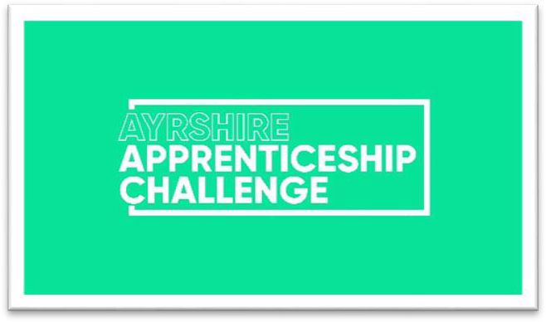

Calling all Ayrshire companies with amazing apprentices!
The Ayrshire Apprenticeship Challenge is back for 2026, offering a fantastic opportunity to give back to your community while developing the skills and talent of your apprentice workforce.

Here's why you should participate:
- Make a positive impact: Your apprentices will plan, develop, and complete a project that benefits your local community. Past projects have included everything from building additions to playgrounds to fundraising for charities!
- Empower your apprentices: The challenge gives them ownership and responsibility
- a chance to shine and showcase their abilities beyond the everyday.
- Boost morale and engagement: Working on a meaningful project together fosters teamwork and creates a more engaged and motivated apprentice team.
- Attract and retain top talent: Highlight your commitment to social responsibility and employee development, making your company a magnet for talented young people.

What kind of projects are eligible?
The sky's the limit! Think building, decorating, event planning, fundraising, raising awareness, or educating. Whether it's physical (like building an item for a community garden) or more administrative (like organising a charity run), the key is to make a positive difference.

Who can enter?
Open to companies with one or more apprentices (Foundation, Modern, or Graduate).
We welcome 3 different types of ‘teams’:
- Individuals
- Company Teams
- Blended teams (Blended teams could be made up of students from the same course at College)

What is the timeline?
- Monday 20th July 2026 - Deadline for Registration
- August- January 2026 – Completion of project
- Tuesday 1st September 2026 – Optional Team building workshop
- Thursday 24th September 2026 – Optional Leadership workshop
- Wednesday 25th November 2026 - Optional Report/Portfolio workshop
- Wednesday 20th January 2027 - Optional Presentation Skills workshop
- Friday 29th January 2027 (no later than 5pm)– Portfolio Submission Deadline
- W/C Monday 1st March 2027 (Exact date TBC) - Final Event during Scottish Apprenticeship Week

Spread the Word!
We encourage you to promote the Ayrshire Apprenticeship Challenge within your company and community.

Social Media Content
We’re keen to showcase the fantastic work apprentices deliver throughout the Ayrshire Apprenticeship Challenge. As part of this, we’d like to capture content across the year, including “Meet the Apprentice(s)” features and behind-the-scenes moments.
We also encourage apprentices to create and share their own videos, which can be featured across our social media channels. To support this, we will provide a toolkit with tips and guidance.
Further details on all marketing activity will be shared in due course. Participation in this activity is entirely optional.

Media Coverage:
To ensure proper recognition for everyone involved, please include the following details in any media coverage related to the Challenge:
- Initiative Name: Ayrshire Apprenticeship Challenge
- Sponsored by: Skills Development Scotland
- Participating Organisers: DYW Ayrshire and Ayrshire Chamber of Commerce
For questions or media release review, contact Ellie Philp ephilp@ayrshire-chamber.org

Ready to join the Challenge?
Fill out the simple registration form below and submit it to Ellie Philp at ephilp@ayrshire-chamber.org by Monday 20th July 2026.

Employer Registration Form
Organisation Name:
Main Contact Name & Job Title:
Main Contact Email:
Company Address:
Telephone Number:
Number of Apprentices Involved:
Names of Apprentices Involved:
Contact Email of ALL Apprentices Involved:
Apprenticeship
Type(s): (Foundation, Modern, Graduate)
Apprenticeship Framework(s):
Proposed Challenge: Briefly describe your project idea.
Project Sourcing Help: Do you need assistance finding a project? | YES | NO
Team Building Workshop-Tuesday 1st September: Are you interested attending and how  many spaces do you require? | YES  No of Spaces: | NO
Leadership Workshop-Thursday 24th September: Are you interested attending and how many spaces do you  require? | YES  No of Spaces: | NO

